
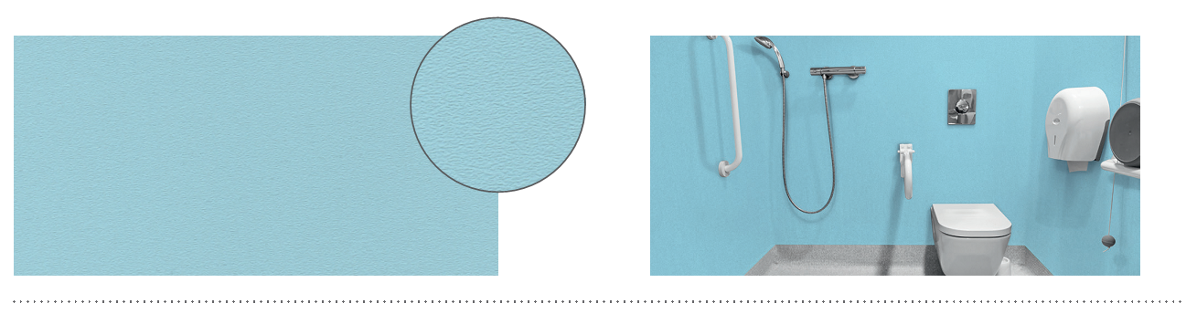

SPECIFICATION

DECOCHOC H₂O
PROTECTION AND COVERING PANEL – 1,5 MM
FOR WET AREAS

- Description: 1,5 mm thick protection and covering panel for wet areas (Decochoc H2O as manufactured by SPM) from rigid and antibacterial PVC achieving Bs2d0 fire rating with solid colour. Its surface is slightly textured with a fine and matte grain finish (Hydr’X grain as manufactured by SPM) perfectly suitable for wet areas due to its water-repellent qualities that limit the development of scale while ensuring optimal scratch resistance. 2.50 m long, 1.30 m high.
- To ensure watertightness of the system, the panels are thermo-welded to each other and to the PVC skirting by means of a welding rod (H2O welding rod as manufactured by SPM). Any connections with other materials are made with a silicone joint (H2O silicone joint as manufactured by SPM). The chemical and mark resistance of the panel should have been proven on the usual cleaning products according to ISO 26987.
- Environment: no heavy metals and no substance potentially subjected to any REACH restriction are used in its manufacture, nor PBT/BPA. The calcium-zinc thermal stabilisation process is used. The emission level of volatile substance in inside air has been tested according to ISO 16000-6 and is very low (A+) according to the French regulation (23 March 2011 nr 2011-321 Decree and 19 April 2011 Order). 100% of the product are recyclable.
- Colours: selected by architects from manufacturer’s standard range.
- Installation method: glue as per manufacturer’s instructions. The installer must have been trained beforehand by the manufacturer to install this system.
